1. Create a new column to show concate 3 string value using dax.

Ans:





2.Create a dax function to show sum of sales on technology and office supply.

Ans:



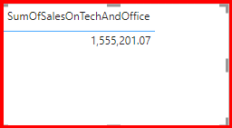

1. Create a report to display top 10 customer who perform maximum sale

Ans:

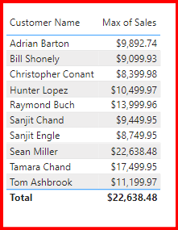

1. Create a dax function that show only weekend sale

Ans:



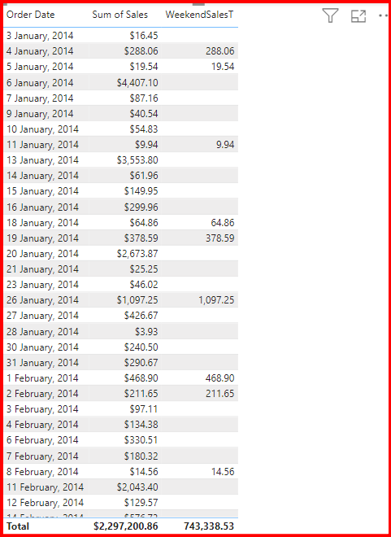

1. Create a report to show sync slicer .

Ans:

